**Homework #05**

**Problem 1 (CTFT)**

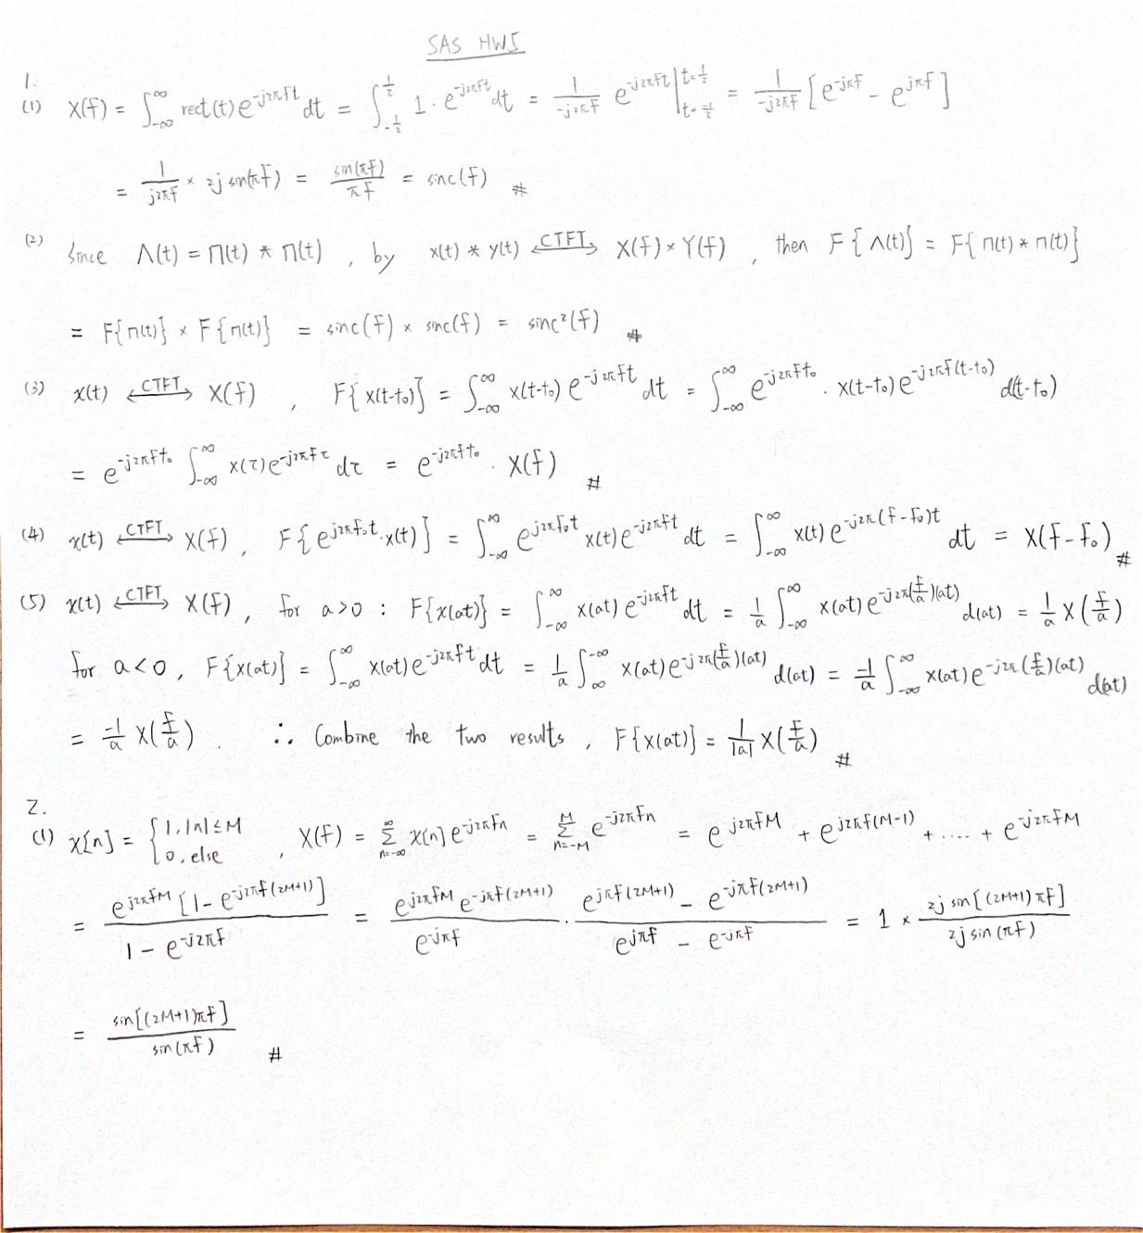

**Problem 2**  **(DTFT)**



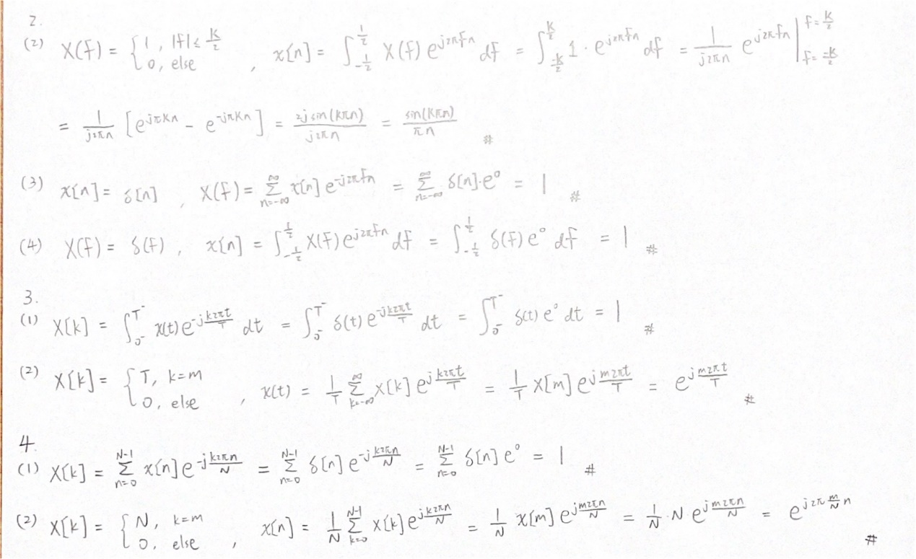

**Problem 3 (CTFS)**

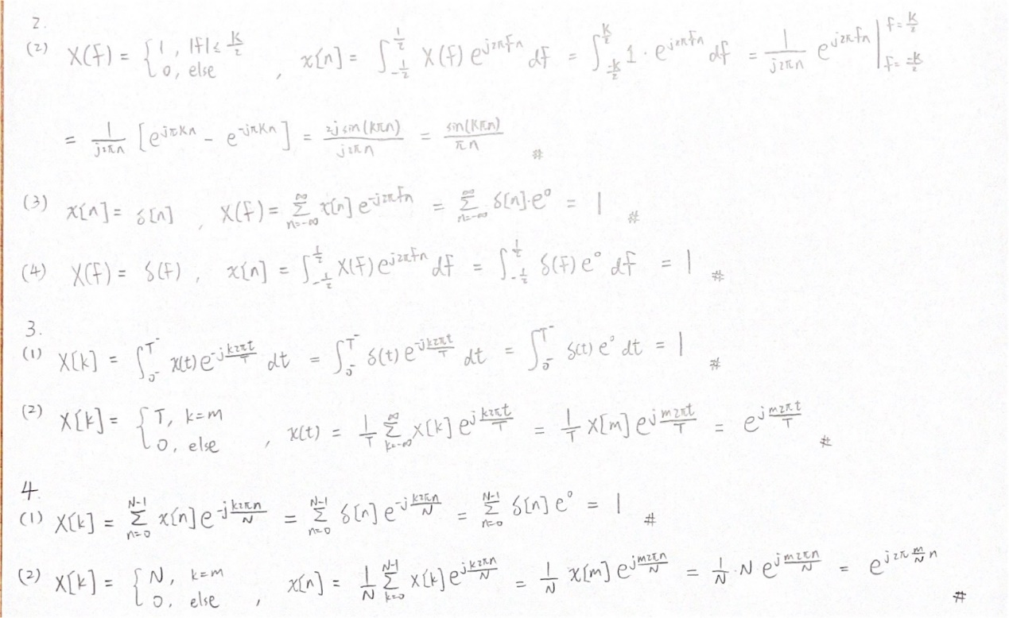

**Problem 4 (DTFS)**

